*Session 17: Assignment 1***1. Introduction**

This assignment will help you to consolidate the concepts learnt in the session.

**2. Problem Statement**

1. Write a program to read a text file and print the number of rows of data in the document.

2. Write a program to read a text file and print the number of words in the document.

3. We have a document where the word separator is -, instead of space. Write a spark

code, to obtain the count of the total number of words present in the document.

ample document :

his-is-my-first-assignment.

-will-count-the-number-of-lines-in-this-document.

he-total-number-of-lines-is-3

1. Write a program to read a text file and print the number of rows of data in the document.

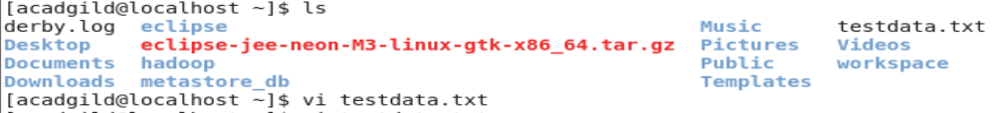

text file is testdata.txt

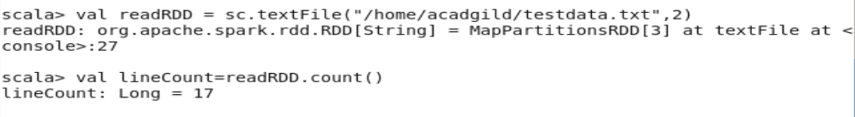

the no of row is 17

2. Write a program to read a text file and print the number of words in the document.

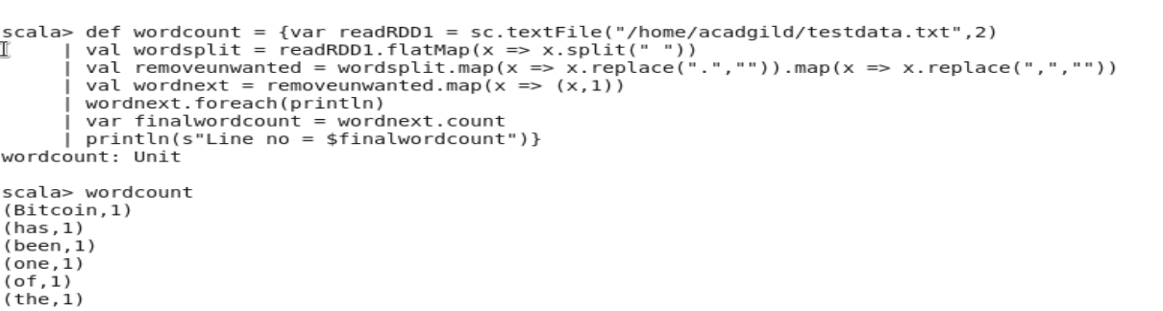

3. We have a document where the word separator is -, instead of space. Write a spark

code, to obtain the count of the total number of words present in the document.

